

Software Engineering

Social Network

TA-Mohamed Samir



November 8, 2014

**Leader Name: Ahmed Abd El-Fattah Abd El-Naem**

**ID: 20120046**

**IT-1**

**Contacts:**

[**Ahmed.donkl@gmail.com**](mailto:Ahmed.donkl@gmail.com)

**Phone:**

**01093030370**

Contents

Team 1

Document Purpose and Audience 2

Introduction 2

Software Purpose 2

Software Scope 2

Definitions, acronyms, and abbreviations 2

Requirements 2

Functional Requirements 3

Non Functional Requirements 3

System Models 3

Use Case Model 3

Use Case Tables 3

Ownership Report 4

# 

# Team

|  |  |  |  |
| --- | --- | --- | --- |
| **ID** | **Name** | **Email** | **Mobile** |
| 20120046 | Ahmed Abd El-fattah | Ahmed.donkl@gmail.com | 01093030370 |
| 20120014 | Ahmed Badr Sayed | Ahmed.badr636@yahoo.com | 01097839631 |
| 20120044 | Ahmed Abd El-ghafar | Ahmedsoud3@gmail.com | 01062471058 |
| 20120049 | Ahmed Abd El-nasser | Asallan23@outlock.com | 01128409572 |

## Audience

The audience includes the client, the users, the project management, the system analysts (i.e., the developers who participate in the requirements), and the system designers (i.e., the developers who participate in the system design).

# Introduction

## Software Purpose

The purpose of this document is to give a detailed description of the requirements for the “back-end API” software for social media. It will illustrate the purpose and complete declaration for the development of this system. It will also explain system constraints, interface and interactions with other external applications.

## Software Scope

In our project we are going to develop a back-end API for social network to enable user to be communicated with other users and to be able to share posts and images and contact with them by messages.

In this system user will have the full experience of being communicated in a full social media network.

This system will enable user to communicate with others by sending them messages, sharing photos with them and also share status (posts) with them.

This system facilitates communicating between users as it enables them to create groups which contain specific number of users who can chat with each other and share photos and status (posts).

This system has two types of users, normal user and premium user which have advanced features.

This system is designed to handle a specific number of users.

More specifically it will be a social media network for a small community such as university or college.

## Definitions, acronyms, and abbreviations

Normal user, the person, who operate or interact directly with the product and its component.

Premium user, the same as normal user but has advanced features.

Public group, groups of some interest with which a user can see all posts and its massages by going to the group's page even the user not member of this group.

Private group, groups of some interest with which members nobody else can see all posts and its massages by going to the group's page.

Page, fan pages of specific entity or product.

Friend, other users that the particular user know them.

Post, text written about what the use is thinking and friends of the user can see it.

Share, sharing statues, videos, pictures…, etc. with the user friends.

Message, text that can be exchanged between users

Hashtag, symbol allows grouping of similarly tagged messages, and also allows an electronic search to return all messages that contain it.

# Requirements

## Functional Requirements

**Sign up:**

**Support user to enter and make his own API identifier to access the system with ID and password, support two types of sign up premium and normal user premium user have features that he can create private groups.**

**Add friend:**

**User should able to add other users to be friends, friends can interact with his page and can make massages to him.**

**User page:**

**Every user should have a page in this page he can add posts like text or photo that can be seen by other friends and they can like the post and share this posts to their pages.**

**Messages:**

**User can send a text message to his friends every user should have messages inbox that he review it.**

**Create a group:**

**Support create a group by user, the group can be shared between specific number of users ,public groups can be joined by any user and private groups can only joined by users that only accepted by group admins ,group admins have the right to delete posts or users.**

**Join group:**

**Users can search a group and join, once you join the group you can add posts to be seen by all group members.**

**Hash tags:**

**Users can add posts and it to a category like education by using "#" like "#sport" when user search the hash tags with sport he can see all sport posts.**

**Fan page:**

**Premium users can create a page and can add post to it that can any users joined the pages and see his posts.**

## Non Functional Requirements

**Interface:**

**Support using GUI to easy use, GUI should allow user to accesses his account than choose between enter a specific page, add user, create group and send message.**

**Usability:**

**New users should have some hints during access specific function to how use it.**

**Implementation:**

**Should implemented with java programing language.**

**Platform:**

**Program support windows 7 and 8 operating system.**

**Performance:**

**The loading of the program should be less than 10 seconds.**

**Security:**

**User cant access other users system.**

# System Models

## Use Case Model

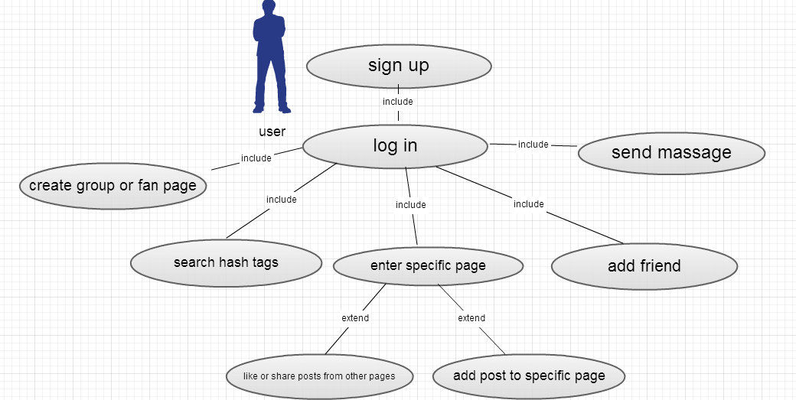

## 

## Use Case Tables

|  |  |  |
| --- | --- | --- |
| Use Case ID: | 1 | |
| Use Case Name: | Sign up | |
| Actosr: | user | |
| Pre-conditions: | User open the program | |
| Post-conditions: | Identify saved and authorized to the system | |
| Flow of events: | **User Action** | **System Action** |
| User enter ID and password | Check for ID and password validation and asked for normal or premium user |
| User choose premium or | System save user identification |
|  |  |
|  |  |
|  |  |
| Exceptions: | none | |
| Includes: | none | |
| Notes and Issues: |  | |

|  |  |  |
| --- | --- | --- |
| Use Case ID: | 2 | |
| Use Case Name: | Log in | |
| Actosr: | user | |
| Pre-conditions: | User enter his identification | |
| Post-conditions: | User access to API menu (add post, send massage,…) | |
| Flow of events: | **User Action** | **System Action** |
| User enter his ID and password | System check for his identification |
|  | Allow user to access API |
|  |  |
|  |  |
|  |  |
| Exceptions: |  | |
| Includes: | Sign up | |
| Notes and Issues: |  | |

|  |  |  |
| --- | --- | --- |
| Use Case ID: | 3 | |
| Use Case Name: | Add user | |
| Actors: | user | |
| Pre-conditions: | user is identified | |
| Post-conditions: | user added a new friend to his friend list | |
| Flow of events: | **User Action** | **System Action** |
| User choose add user from API menu | System asked user for the friend name |
| User enter friend name | System search for the name and add it to his friend list |
|  |  |
|  |  |
|  |  |
| Exceptions: |  | |
| Includes: | Log in | |
| Notes and Issues: |  | |

|  |  |  |
| --- | --- | --- |
| Use Case ID: | 4 | |
| Use Case Name: | Send message | |
| Actors: | user | |
| Pre-conditions: | user is identified | |
| Post-conditions: | Message sanded to user friend | |
| Flow of events: | **User Action** | **System Action** |
| User chooses to send message. | System asked user to enter the text |
| User enter the text message | System asked user for the reciver |
| User enter receiver name | System send message to the receiver |
|  |  |
|  |  |
| Exceptions: |  | |
| Includes: | Log in | |
| Notes and Issues: |  | |

|  |  |  |
| --- | --- | --- |
| Use Case ID: | 5 | |
| Use Case Name: | Create group or fan page | |
| Actosr: | user | |
| Pre-conditions: | User identified | |
| Post-conditions: | User add a group or fan page to the system | |
| Flow of events: | **User Action** | **System Action** |
| User chooses to create group or page | System asked user for page name |
| User enter page name | System save the page to the system |
|  |  |
|  |  |
|  |  |
| Exceptions: |  | |
| Includes: | Log in | |
| Notes and Issues: |  | |

|  |  |  |
| --- | --- | --- |
| Use Case ID: | 6 | |
| Use Case Name: | Hash tags | |
| Actosr: | user | |
| Pre-conditions: | User is identified | |
| Post-conditions: | A list of a specific post shown | |
| Flow of events: | **User Action** | **System Action** |
| User select hash tags | System asked user for the category name |
| User enter the name | System list the posts |
| 3- User Select Vodafone from the list |  |
|  |  |
|  |  |
| Exceptions: |  | |
| Includes: | Log in | |
| Notes and Issues: |  | |

|  |  |  |
| --- | --- | --- |
| Use Case ID: | 7 | |
| Use Case Name: | Enter specific page | |
| Actosr: | user | |
| Pre-conditions: | User is identified | |
| Post-conditions: | User can surf the page posts | |
| Flow of events: | **User Action** | **System Action** |
| User select to go to a page | System asked for the page |
| User select his page or search another page | System go to the page |
|  |  |
|  |  |
|  |  |
| Extend: | Add post , share and like post | |
| Includes: | Log in | |
| Notes and Issues: |  | |

|  |  |  |
| --- | --- | --- |
| Use Case ID: | 8 | |
| Use Case Name: | Add post | |
| Actosr: | User | |
| Pre-conditions: | Is identified and enter the specific page | |
| Post-conditions: | Post is added to the page | |
| Flow of events: | **User Action** | **System Action** |
| enter a page and select add post | Asked user to enter the post |
| User enter the txt |  |
|  |  |
|  |  |
|  |  |
| Exceptions: |  | |
| Includes: | enter specific page | |
| Notes and Issues: |  | |

|  |  |  |
| --- | --- | --- |
| Use Case ID: | 9 | |
| Use Case Name: | Like or share post | |
| Actors: | user | |
| Pre-conditions: | Enter the page | |
| Post-conditions: | Post liked or shared to the user page | |
| Flow of events: | **User Action** | **System Action** |
| user select a post | System asked user to share or like |
| User select share or like | Post shared to the user page or have liked sign |
|  |  |
|  | s |
|  |  |
| Exceptions: |  | |
| Includes: | Enter specific page | |
| Notes and Issues: |  | |

# 

# Ownership Report

|  |  |
| --- | --- |
| **Item** | **Owners** |
| Requirement | *Ahmed Abd El-ghafar* |
| Definitions & purpose | *Ahmed Abd El- Nasser* |
| SRS Scope | *Ahmed Badr Sayed* |